Spontaneous Potential 4



**GENERAL**

The spontaneous potential (SP) log was one of the earliest measurements used in the petroleum industry, and it has continued to play a significant role in well log interpretation. Most wells today have this type of log included in their log suites. Primarily, the SP log is used for determining gross lithology (i.e., reservoir vs. nonreservoir) through its ability to distinguish permeable zones (such as sandstones) from impermeable zones (such as shales). It is also used to correlate zones between wells. However, as will be discussed later in this chapter, the SP log has several other uses that are perhaps equally important.

The SP log is a record of direct current (DC) voltage (or *potential*) that develops naturally (or *spontaneously*) between a moveable electrode in the well bore and a fixed electrode located at the surface. It is measured in millivolts (mV). Electric voltages arising primarily from electrochemical factors within the borehole and the adjacent rock create the SP log response. These electrochemical factors are brought about by differences in salinities between mud filtrate and formation water within permeable beds.

Salinity of a fluid is inversely proportional to its resistivity, and in practice salinity is indicated by mud filtrate resistivity (*Rmf*) and formation water resistivity (*Rw*). Because a conductive fluid is needed in the borehole for the generation of these voltages, the SP cannot be used in nonconductive (e.g., oil-base) drilling muds or in air-filled holes.

The SP log is usually recorded on the left track of the log (track 1) and is used to

• detect permeable beds

• detect boundaries of permeable beds

• determine formation-water resistivity (*Rw*)

• determine the volume of shale in permeable beds

An auxiliary use of the SP curve is in the detection of hydrocarbons by the suppression of the SP response.

The concept of static spontaneous potential (*SSP*) is important because *SSP* represents the maximum SP that a thick, shale-free, porous, and permeable formation can have for a given ratio between *Rmf* and *Rw*.

*SSP* is determined by formula or chart and is a necessary element for determining accurate values of *Rw* and volume of shale. The measured *SP* value is influenced by bed thickness, bed resistivity, borehole diameter, invasion, shale content, hydrocarbon content, and most important: the ratio of *Rmf* to *Rw* (Figure 4.1A).

***Bed Thickness***

In a thin formation (i.e., less than about 10 ft [3 m] thick), the measured *SP* is less than *SSP* (Figure 4.1B).

However, the SP curve can be corrected by chart for the effects of bed thickness. As a general rule, whenever the SP curve is narrow and pointed, the *SP* should be corrected for bed thickness before being used in the calculation of *Rw*.

***Bed Resistivity***

Higher resistivities reduce the deflection of the SP curves.

***Borehole and Invasion***

The effects of borehole diameter and invasion on the SP log are very small and, in general, can be ignored.

***Shale Content***

The presence of shale in a permeable formation reduces the SP deflection (Figure 4.1B). In water-bear-ing zones, the amount of SP reduction is related to the amount of shale in the formation.

***Hydrocarbon Content***

In hydrocarbon-bearing zones, the SP deflection is reduced. This effect is called *hydrocarbon suppression*. Hydrocarbon suppression of the SP is a qualitative phenomenon, and cannot be used to determine the hydrocarbon saturation of the formation.

The SP response of shales is relatively constant and follows a straight line called a *shale baseline*. The *SP* value of the shale baseline is assumed to be zero, and SP curve deflections are measured from this baseline.

Permeable zones are indicated where there is SP deflection from the shale baseline. For example, if the SP curve moves either to the left (negative deflection; *Rmf* > *Rw*) or to the right (positive deflection; *Rmf* < *Rw*) of the shale baseline, permeable zones are present. Permeable bed boundaries are placed at the points of inflection from the shale baseline.

Note that when recording through impermeable zones or through permeable zones where *Rmf* is equal to *Rw*, the SP curve does not deflect from the shale baseline. The magnitude of SP deflection is due to the difference in salinity between mud filtrate and formation water and not to the amount of permeability. This salinity difference produces a difference in the resistivities of the mud filtrate (*Rmf*) and formation water (*Rw*).

Over long intervals (several hundreds to thousands of feet), the SP baseline can drift, either in the positive or negative direction. While this is of little consequence when making calculations local to a specific formation, it may introduce errors if the SP magnitude is being calculated over that long interval, especially by means of a computer. Accordingly, the baseline drift can be removed (many programs have such editing routines) so that the SP baseline retains a constant value (usually set to zero) over the length of the logged interval.

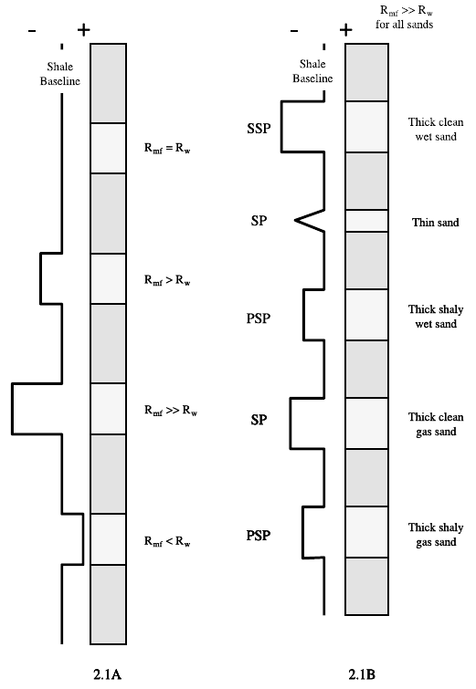

**Figure 4.1.** Examples of SP deflection from the shale baseline.

**4.1A.** SP deflection with different resistivities of mud filtrate (*Rmf*) and formation water (*Rw*). Where resistivity of the mud filtrate (*Rmf*) is equal to the resistivity of the formation water (*Rw*), there is no deflection, positive or negative, from the shale baseline.

Where *Rmf* is greater than *Rw*, the SP deflects to the left of the shale baseline (negative deflection). Where *Rmf* greatly exceeds *Rw*, the deflection is proportionately greater. This is often called a *normal* SP.

Where *Rmf* is less than *Rw*, the SP deflects to the right of the shale baseline (positive deflection). This condition, often called a *reversed* SP, is produced by a formation containing fresh water.

Remember, the SP log can used only with conductive (i.e., saltwater base or freshwater base) drilling muds. This log does not work with oil-base muds or in air-filled holes.

**4.1B.** SP deflection with resistivity of the mud filtrate (*Rmf*) much greater than formation water (*Rw*). *SSP* (static spontaneous potential) at the top of the diagram, is the maximum deflection possible in a thick, shale-free, and water-bearing (*wet*) sandstone for a given ratio of *Rmf* /*Rw*. All other deflections are less and are relative in magnitude.

SP shows the SP response due to the presence of thin beds and/or the presence of gas. *PSP* (pseudostatic spontaneous potential) is the SP response if shale is present.

The formula for the theoretical calculated value of *SSP* is given:

4.3

where:

3.3

**Table 4.1.** Mathematical Calculation of *Rw* from *SSP*, for temperatures in °F.

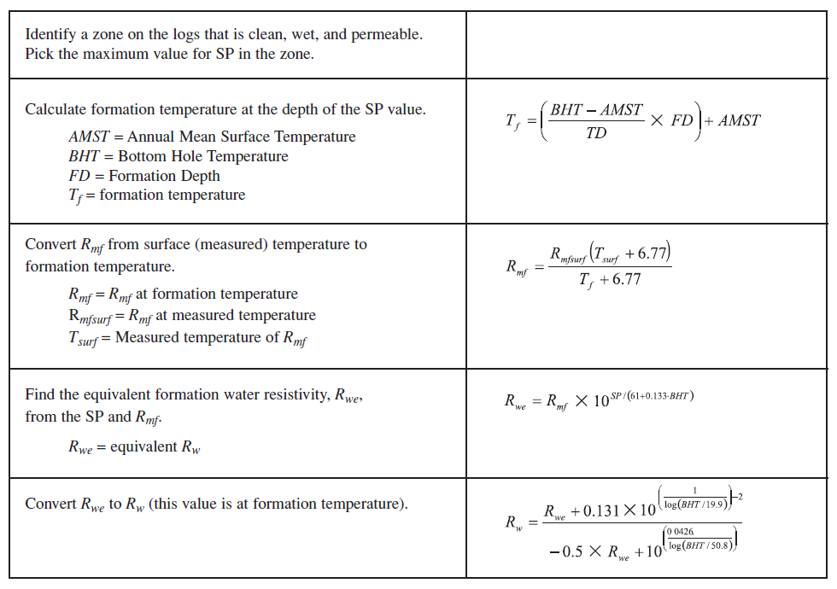



**Figure 4.2.** Determination of formation water resistivity (*Rw*) from an SP log

.

**Shale Volume Calculation**

The volume of shale in a sand can be used in the evaluation of shaly sand reservoirs and as a mapping parameter for both sandstone and carbonate facies analysis. The SP log can be used to calculate the volume of shale in a permeable zone by the following formula:

4.1

where:

*Vshale =* volume of shale

*PSP =* pseudostatic spontaneous potential (maximum SP of shaly formation)

*SSP =* static spontaneous potential of a nearby thick clean Sand

Or, alternately:

4.2

where:

*Vshale =* volume of shale

*PSP =* pseudostatic spontaneous potential (maximum SP of shaly formation)

*SSP =* static spontaneous potential of a nearby thick clean sand

*SPshale =* value of SP in a shale (usually assumed to be zero)

**Formation Water Resistivity (*Rw*) Determination**

Figure 4.2 is an induction electric log with an SP curve. In this example, the SP curve is used to find a value for *Rw* by the following procedure: